## Input a String S, and check its length and if the length is greater than 4, truncate the input String and output the result.

Input: Ice Output: Ice

Input: Icecream Output:Icec…

var str = ""

function truncateString(str, num) {

if (str.length > num) {

return str.slice(0, num) + "...";

} else {

return str;

}

}

console.log(truncateString("Ice", 4));

console.log(truncateString("Icecream", 4));

***Running this in VsCode***

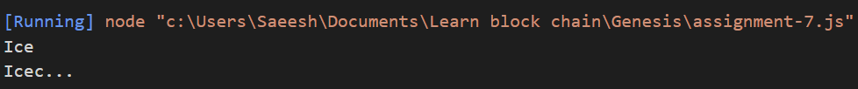

## Input a String S with multiple words, and remove whitespaces and output the result -

Input: “Hii Boy” Output: “HiiBoy”

function trimString(x){

const result = x.replace(/\s/g, '');

return result;

}

const result = trimString("Hii Boy");

console.log(result);

***Running this in VsCode***



## Input a String S with two words, and replace first word with second word and display the result -

Input: “Hii Boy” Output: “Boy Hii”

let str = "Hii Boy";

let part1 = str.slice(0,3);

let part2 = str.slice(4,8);

let newStr = (part2 + " " + part1);

console.log(newStr);

***Running this in VsCode***



## Input a String S with a word, and replace character “a” with “x” and display the result -.

Input: “apple” Output: “xpple”

let str = "Apple";

let part = str.slice(1);

let newStr = "x" + part;

console.log(newStr);

***Running this in VsCode***



## What string method can be used to convert string into array ?

The string in JavaScript can be converted into a character array by using the split() and Array.from() functions.

**Using String split() Function**: The str.split() function is used to split the given string into array of strings by separating it into substrings using a specified separator provided in the argument.

**Using Array.from() Function**: The Array.from() function is an inbuilt function in JavaScript which creates a new array instance from a given array. In case of a string, every alphabet of the string is converted to an element of the new array instance and in case of integer values, new array instance simple take the elements of the given array.

## What string method can be used to check the occurrence of a specified text in a string?

The indexOf() method, given one argument: a substring to search for, searches the entire calling string, and returns the index of the first occurrence of the specified substring.

## How can you break a string to a newline in Javascript?

The newline character is **\n** in JavaScript. All you need to do is add **\n** character whenever you require a line break to add a new line to a string.

## Write a Javascript function to test whether the first character of a string is lowercase?

function lower_case(str)

{

regexp = /^[a-z]/;

if (regexp.test(str))

{

console.log("String's first character is lowercase");

}

else

{

console.log("String's first character is not lowercase");

}

}

lower_case("Archimedes");

lower_case("archimedes");

***Running this in VsCode***

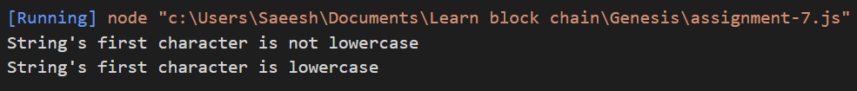

## Give a correct verdict to users input if he enters "yes", "YES","Yes" ,etc (any combination) using string methods. How will you handle that?

We consider each input as a separate entity and search it in dictionary. If the value is present in dictionary, we recur for the string and use the replace function

Dictionary will be {yes, yeS, yES, YES, YEs, Yes, yEs} to correct it to the required value.

## Given a String S, achieve following tasks

### Convert the String into upper case

const str = "Hello World!";

let str2 = str.toUpperCase()

console.log(str2);

***Running this in VsCode***



### Convert only the first character to uppercase.

const str = "Hello World!";

let str2 = str.charAt(0).toUpperCase() + str.slice(1).toLowerCase();

console.log(str2);

***Running this in VsCode***



### Convert the String into lower case

const str = "Hello World!";

let str2 = str.toLowerCase()

console.log(str2);

***Running this in VsCode***



### Break the string into two halves and swap them.

const str = "Hello World!";

let part1 = str.substring(0,5);

let part2 = str.substring(6,12);

const newStr = (part2 + " " + part1);

console.log(newStr);

***Running this in VsCode***

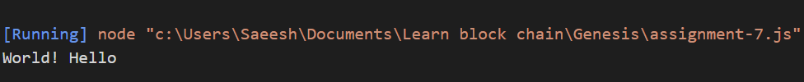

### Count the repeating characters.

const str = "Hello World!";

const repeatLetter = (str = '') => {

const strArr = str.split("").sort();

let count = 1;

let i = 1;

let res = '';

while (i < strArr.length) {

if (strArr[i - 1] === strArr[i]) { count++; }

else {

res += count + strArr[i - 1];

count = 1;

}; i++;

}; res += count + strArr[i - 1];

return res;

};

console.log(repeatLetter(str));

***Running this in VsCode***



### Reverse the string

const str = "Hello World!";

function ReverseString(str){

return[...str].reduce((x,y) => y.concat(x));

}

console.log(ReverseString(str));

***Running this in VsCode***

